**2.2 Hot Probe:**

Voltage is seen to increase in negative voltage, so we see that it is p-type.

**2.3 Four Point Probe:**

|  |  |  |
| --- | --- | --- |
| V (Volts) | I (Amps) | Resistivity (Ohms per cm) |
| 0.0239 | 0.000243 | 13.4 |

**2.4 Sheet Resistance:**

|  |  |  |
| --- | --- | --- |
| V1,4 | I1,4 | R1,4 |
| 3.529 | 1.284 x 10-3 | 2738 |

|  |  |  |
| --- | --- | --- |
| V2,3 | I1,4 | Rx1,x2 |
| 2.338 | 1.39 x 10-3 | 1682 |

**2.5 Measurement of Finished Diode:**

Forward:

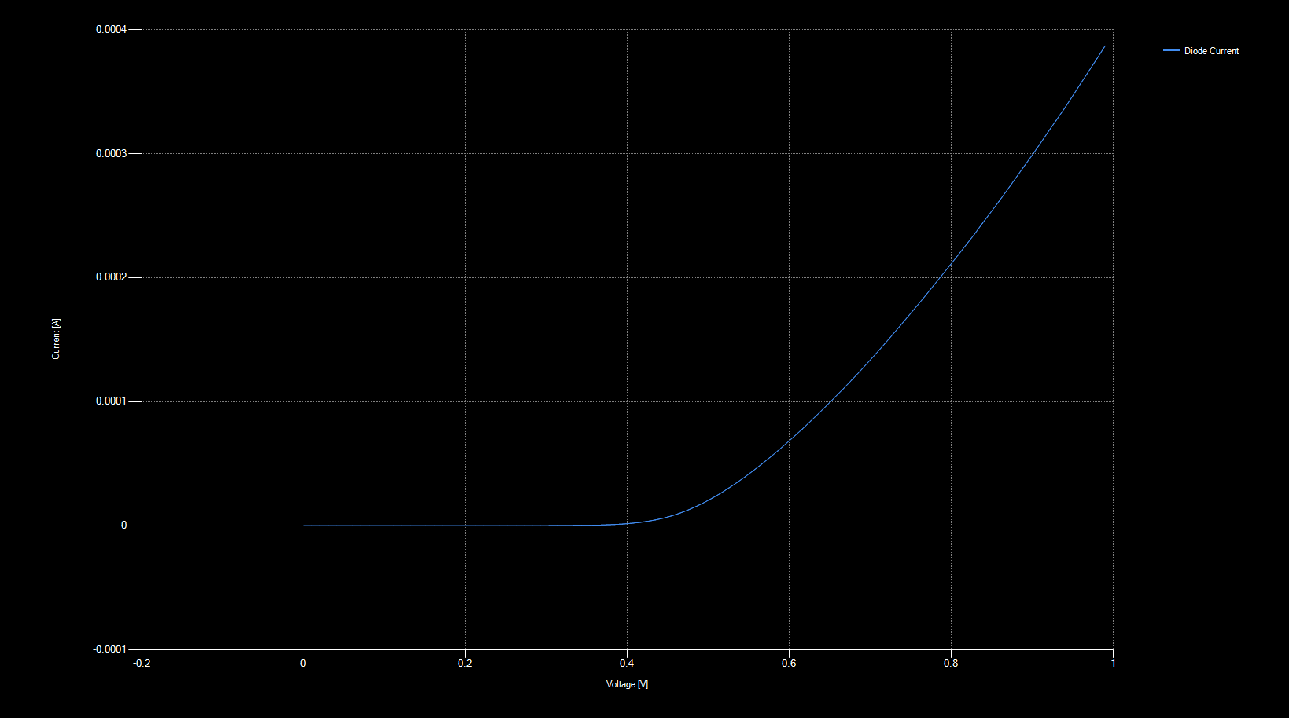

Reverse No Light

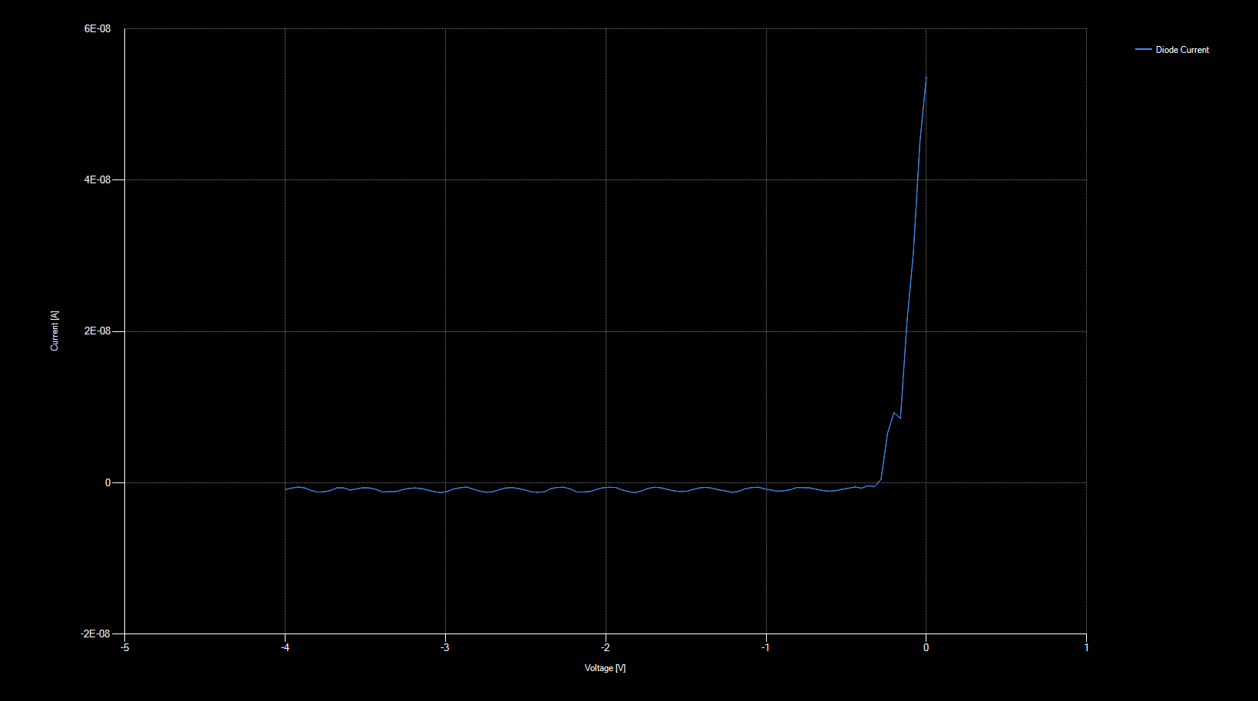

Reverse Mid Light (45)

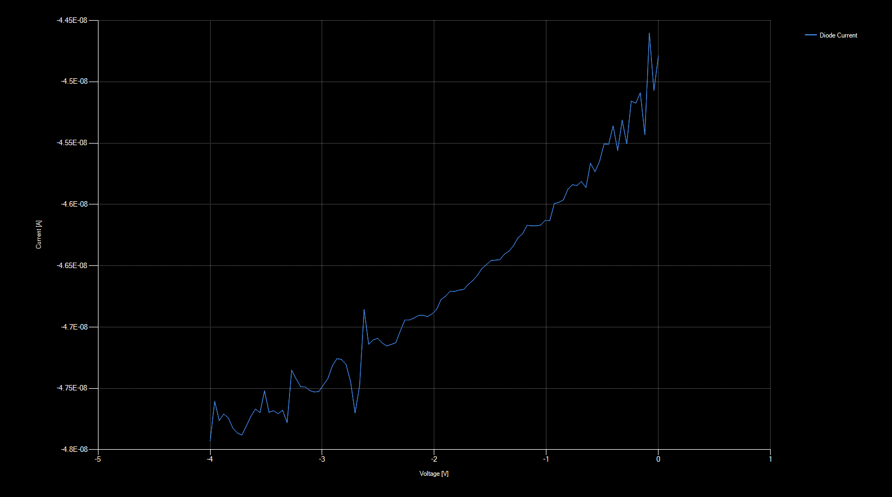

Reverse High Intensity Light (90)

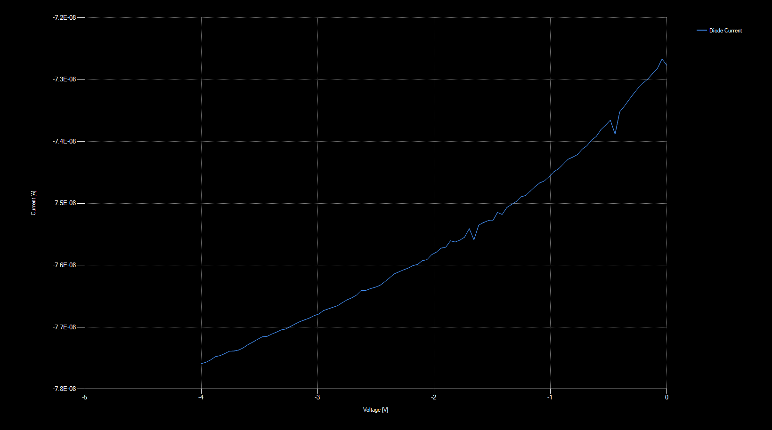

2.6 Switching Diode:

|  |  |  |  |  |
| --- | --- | --- | --- | --- |
|  | Vf (V) | Vr (V) | tf (microseconds) | ts (microsecond) |
| 1 | **5** | -5 | 50 | 2.22 |
| 2 | **9** | -1 | 50 | 8.95 |
| 3 | **3** | -7 | 50 | 0.47 |
| 4 | **5** | -5 | 5 | 1.06 |